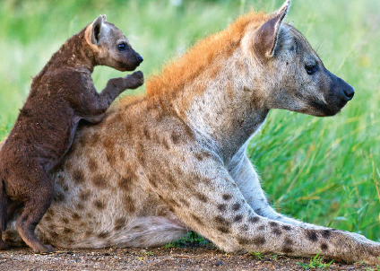
Chapitre 7 : tâche complexe
2. Comment les animaux se développent-ils ?
Je me documente – page 150
Relations entre les parents et leurs enfants

ÉNONCÉ DE LA TÂCHE COMPLEXE

À partir des documents de la page 150 et de tes connaissances, explique comment les parents s’occupent de leurs petits.

……………………………………………………………………………………………………………………………………………………………….

……………………………………………………………………………………………………………………………………………………………….
……………………………………………………………………………………………………………………………………………………………….

……………………………………………………………………………………………………………………………………………………………….
……………………………………………………………………………………………………………………………………………………………….

……………………………………………………………………………………………………………………………………………………………….
……………………………………………………………………………………………………………………………………………………………….

……………………………………………………………………………………………………………………………………………………………….
……………………………………………………………………………………………………………………………………………………………….

……………………………………………………………………………………………………………………………………………………………….
……………………………………………………………………………………………………………………………………………………………….

……………………………………………………………………………………………………………………………………………………………….
……………………………………………………………………………………………………………………………………………………………….

……………………………………………………………………………………………………………………………………………………………….
……………………………………………………………………………………………………………………………………………………………….

……………………………………………………………………………………………………………………………………………………………….
……………………………………………………………………………………………………………………………………………………………….

……………………………………………………………………………………………………………………………………………………………….

