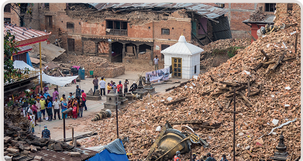
Chapitre 15 : tâche complexe
2 Qu’est-ce qu’un séisme ?
Je me documente – page 318
risques sismique, moyens de protection

ÉNONCÉ DE LA TÂCHE COMPLEXE

En utilisant les documents page 318 et tes connaissances, explique les conséquences d’un séisme et comment les populations peuvent se protéger.

……………………………………………………………………………………………………………………………………………………………….

……………………………………………………………………………………………………………………………………………………………….
……………………………………………………………………………………………………………………………………………………………….

……………………………………………………………………………………………………………………………………………………………….
……………………………………………………………………………………………………………………………………………………………….

……………………………………………………………………………………………………………………………………………………………….
……………………………………………………………………………………………………………………………………………………………….

……………………………………………………………………………………………………………………………………………………………….
……………………………………………………………………………………………………………………………………………………………….

……………………………………………………………………………………………………………………………………………………………….
……………………………………………………………………………………………………………………………………………………………….

……………………………………………………………………………………………………………………………………………………………….
……………………………………………………………………………………………………………………………………………………………….

……………………………………………………………………………………………………………………………………………………………….
……………………………………………………………………………………………………………………………………………………………….

……………………………………………………………………………………………………………………………………………………………….
……………………………………………………………………………………………………………………………………………………………….

……………………………………………………………………………………………………………………………………………………………….

