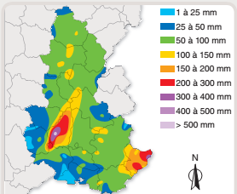
Chapitre 15 : tâche complexe
1 Quels sont les risques météorologiques ?
Je me documente – page 314
risques d’inondations, moyens de prévention

ÉNONCÉ DE LA TÂCHE COMPLEXE

En utilisant les documents page 314 et tes connaissances, explique l’origine des inondations et indique les moyens mis en place pour protéger les populations.

……………………………………………………………………………………………………………………………………………………………….

……………………………………………………………………………………………………………………………………………………………….
……………………………………………………………………………………………………………………………………………………………….

……………………………………………………………………………………………………………………………………………………………….
……………………………………………………………………………………………………………………………………………………………….

……………………………………………………………………………………………………………………………………………………………….
……………………………………………………………………………………………………………………………………………………………….

……………………………………………………………………………………………………………………………………………………………….
……………………………………………………………………………………………………………………………………………………………….

……………………………………………………………………………………………………………………………………………………………….
……………………………………………………………………………………………………………………………………………………………….

……………………………………………………………………………………………………………………………………………………………….
……………………………………………………………………………………………………………………………………………………………….

……………………………………………………………………………………………………………………………………………………………….
……………………………………………………………………………………………………………………………………………………………….

……………………………………………………………………………………………………………………………………………………………….
……………………………………………………………………………………………………………………………………………………………….

……………………………………………………………………………………………………………………………………………………………….

